
UBER TRIPS ANALYSIS DOCUMENTATION

NAME NARMADHA V
CLASS : II B.Sc. AI&ML
BATCH : DATA SCIENCE

Data Science
Data Science is the process of collecting, organizing, analyzing, and interpreting large amounts of data to extract useful information and make better decisions.It combines different fields such as statistics, mathematics, and computer science to study data and find patterns. Data Science is widely used in companies like Uber, Amazon, Netflix, and others to improve services and understand user behavior.
In simple terms, Data Science helps convert raw data into meaningful insights.

Life Cycle:
The general steps in a Data Science:

Problem Statement
Uber is a popular ride-sharing company that allows users to book taxis through a mobile app. Every day, thousands of rides happen in different cities at different times.
However, Uber needs to understand:
- When most people book rides
- Which areas have high demand
- How fare changes based on distance and time

Explanation:
- Uber collects large amounts of trip data every day
- This data is not useful unless it is analyzed properly
- By studying this data, we can find useful patterns
- These patterns help Uber improve service and pricing

Main Problem:
To analyze Uber trip data and find useful patterns that can help improve ride planning, pricing, and customer experience.

LIFECYCLE (PROCESS)

- DATA COLLECTION
Data collection is the first and most important step in the data science process. In this stage, raw data is gathered from different sources such as databases, websites, or public datasets. In this project, Uber trip data is collected from Kaggle, which contains information about rides, locations, and fares.

Dataset Information:
- Dataset Name: Uber Trips Dataset
- Source: Kaggle (public dataset)
- Type: Structured dataset (table format)

Columns in Dataset:
- Pickup location (where ride started)
- Drop location (where ride ended)
- Date and time of trip
- Distance traveled
- Fare amount paid
- Other trip details

Below is a sample view of the dataset used in this project. It contains information about Uber rides such as pickup location, drop location, distance, fare, and time of travel.

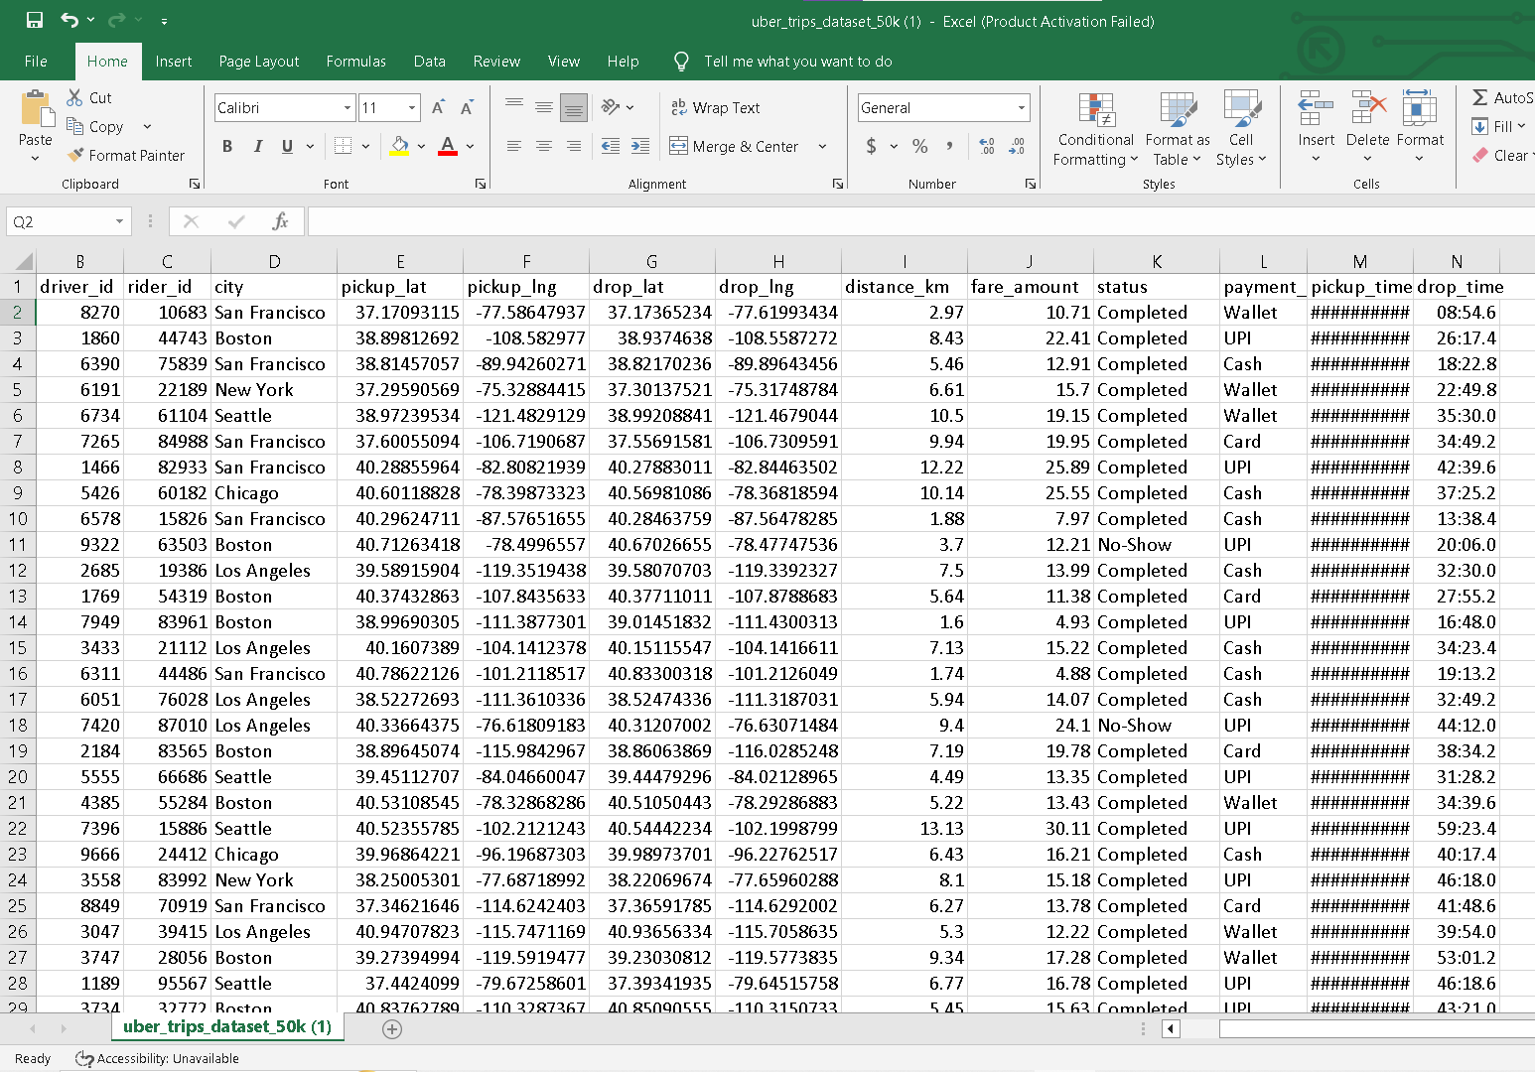

- DATA CLEANING
Data cleaning is the process of removing incorrect, missing, or duplicate data from the dataset. This is important because raw data usually contains errors that can affect the final result. For example, if fare value is negative or zero, it is removed to maintain accuracy.

Steps in Data Cleaning:
- Removing Missing Values
- Empty rows or missing values are removed or corrected

- Fixing Date and Time Format
- Convert time into proper format
- Helps in analyzing peak hours

- Removing Incorrect Values
- Remove rides with:
  - negative fare
  - zero fare
  - invalid distance

- Handling Duplicate Data
- Remove repeated entries
- Keep only one correct record

- Standardizing Data
- Make sure all values follow same format

Result of Cleaning:
- Clean and accurate dataset
- Ready for analysis and modeling

- EXPLORATORY DATA ANALYTICS (EDA)
EDA is the process of studying and understanding the dataset using simple analysis and visual methods. It helps to find patterns, trends, and relationships in the data. In this project, EDA is used to analyze peak ride times, popular locations, and the relationship between fare and distance.
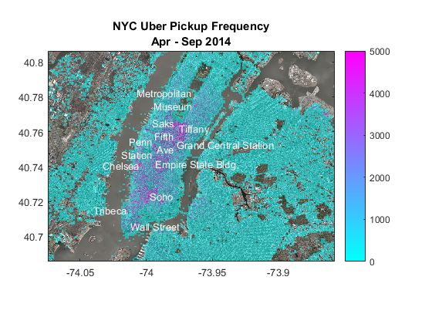
1. Peak Time Analysis
We analyze when most Uber rides happen.
Findings:
- Morning time (7 AM – 10 AM): High demand
- Evening time (5 PM – 9 PM): Highest demand
- Night time: Low demand

2. Pickup Location Analysis
We study where most rides start.
Findings:
- City centers have highest pickups
- Railway stations and airports have high demand
- Residential areas show moderate usage

3. Fare vs Distance Analysis
We check how fare changes with distance.
Findings:
- Short distance → low fare
- Long distance → high fare
- Fare increases steadily with distance

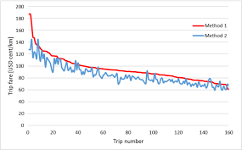

4. Day of Week Analysis
We study rides based on weekdays.
Findings:
- Weekdays: More rides (office travel)
- Weekends: Slightly fewer rides

5. Ride Pattern Analysis
We observe general travel behavior.
Findings:
- Repeated rides in same areas
- High demand during office hours
- Low demand late night

- MODEL BUILDING
Model building is the stage where a machine learning model is created using the dataset. The model learns patterns from past data and uses them to make predictions. In this project, a simple regression model can be used to predict Uber fare based on distance and other factors.

Input:
- Distance of trip
- Time of ride
- Pickup location
- Drop location
- Day of the week
Output:
- Estimated fare amount
Simple Model Idea:
- If distance increases → fare increases
- If demand is high → fare may increase
- Model learns from past data

This diagram shows how the machine learning model is trained using historical Uber trip data. The model learns patterns between distance, time, and fare to predict future ride prices.

- EVALUATION
Evaluation is used to check how accurate the model is after building it. The predicted results are compared with actual values to measure performance. In this project, errors like MAE or RMSE can be used to understand how well the model is working.

Steps:
- Compare predicted fare with actual fare
- Measure difference (error)
- Check overall accuracy

Result:
- Low error → Good model
- High error → Needs improvement

- DEPLOYMENT
Deployment means using the trained model in a real-world system or application. It allows users to get predictions from the model in real time. In this project, it can be imagined that Uber uses the model to show estimated fare before booking a ride.

How Uber can use it:
- Show estimated fare before booking ride
- Help users plan travel cost
- Improve pricing system

Real-Life Use:
- Mobile app integration
- API system for fare prediction
- Live trip estimation system

This diagram shows how the trained model is used in a real application. When a user enters trip details in the Uber app, the system processes the data and gives a predicted fare instantly.

- MONITORING
Monitoring is the final step where the performance of the model is continuously checked over time. It ensures that the model is still giving correct results even when data changes. If performance decreases, the model is updated with new data to improve accuracy.

Monitoring Steps:
- Check prediction accuracy regularly
- Update model with new data
- Improve model performance over time

Conclusion
This project on Uber trip data analysis using the Data Science process helps us understand how data can be used to find useful patterns in real-life situations. By studying the dataset, we were able to observe important factors such as ride demand during different time periods, popular pickup locations, and the relationship between distance and fare. The steps of data science like data collection, data cleaning, exploratory data analysis, model building, evaluation, and deployment helped in organizing the work in a clear and structured manner. This project shows how Uber can use data to improve ride services, optimize pricing, and enhance customer experience. Overall, it gives a basic understanding of how data science is applied in real-world applications.

Key Learnings:
- Most rides happen during office hours
- Distance affects fare directly
- City areas have high demand
- Data analysis helps improve business decisions

